**Chapter -1**

**Introduction to computer system**

1. **What are the different characteristics of the computer?** **A computer is an electronic device capable of processing data according to instructions stored in its memory. It can perform various tasks, such as calculations, data processing, communication, and multimedia operations. Computers operate based on the principles of digital logic and can execute a wide range of software programs to fulfill diverse user needs.**

**Processing Power: Computers possess the ability to execute instructions and perform calculations, determined by the speed and efficiency of their central processing unit (CPU).**

**Storage Capacity: They can store vast amounts of data, ranging from text files to multimedia content, utilizing primary storage (RAM) and secondary storage (hard drives, solid-state drives, etc.).**

**Memory (RAM): Computers utilize Random Access Memory (RAM) to temporarily store data actively being used, allowing for quick access and efficient processing.**

**Input/Output Devices: These include peripherals like keyboards, mice, monitors, printers, and scanners, enabling users to interact with the computer and receive output.**

**Connectivity: Computers can connect to networks, other devices, and the internet, facilitating communication, data transfer, and access to online resources.**

**Operating System: The operating system (e.g., Windows, macOS, Linux) manages hardware resources and provides a user interface for interacting with the computer.**

**Software: Applications and programs run on computers to perform specific tasks, such as word processing, graphic design, gaming, and more.**

**Portability: While traditional desktop computers are stationary, laptops, tablets, and smartphones offer varying degrees of portability, allowing users to work or access information on the go.**

**Scalability: Computers can often be upgraded with additional hardware components or software updates to enhance performance or add new features.**

**Reliability: Modern computers are designed to operate reliably for extended periods, with built-in mechanisms to detect and recover from errors.**

**Word Length, Speed, Storage, Accuracy, Diligence, Versatility, Non-Intelligence: These additional characteristics further define a computer's capabilities, including its processing capabilities, data handling, reliability, and limitations**

1. **Explain computer architecture in detail.**

**Computer architecture refers to the design and organization of the various components that make up a computer system and how they interact to perform tasks. It encompasses hardware components such as the CPU, memory, input/output devices, and the interconnections between them, as well as the system's instruction set architecture (ISA) and organization.**

**Here's an overview of computer architecture and the two primary architectural models: Von Neumann architecture and Harvard architecture:**

**Von Neumann Architecture:**

**The Von Neumann architecture, proposed by mathematician and physicist John von Neumann in the 1940s, is the basis for most modern computer designs. It consists of the following main components:**

**Central Processing Unit (CPU): Responsible for executing instructions and performing calculations. It comprises an Arithmetic Logic Unit (ALU) for mathematical and logical operations and a Control Unit (CU) for instruction decoding and execution control.**

**Memory Unit: Stores both data and instructions that the CPU can access. In the Von Neumann architecture, instructions and data are stored in the same memory space, allowing instructions to be treated as data and manipulated accordingly.**

**Input/Output (I/O) Devices: Facilitate communication between the computer and the external world. These include devices like keyboards, mice, monitors, printers, and storage devices.**

**System Bus: Provides pathways for data and instructions to travel between the CPU, memory, and I/O devices. It consists of address lines, data lines, and control lines.**

**In Von Neumann architecture, instructions and data are fetched from memory sequentially, processed by the CPU, and then stored back to memory or sent to output devices.**

**Harvard Architecture:**

**The Harvard architecture, named after the Harvard Mark I relay-based computer, is a computer architecture with physically separate storage and signal pathways for instructions and data. Key features include:**

**Separate Memory Spaces: Harvard architecture uses separate memory units for instructions and data. This allows the CPU to fetch instructions and access data simultaneously, potentially improving performance.**

**Dual Buses: Harvard architecture typically employs separate buses for instructions and data, reducing contention and enabling parallelism in memory access.**

**Instruction Cache: In many Harvard architecture implementations, there is an instruction cache to store frequently accessed instructions, further enhancing performance.**

**Harvard architecture is commonly found in microcontrollers and embedded systems where performance and efficiency are critical.**

**3 ) discuss the classification of computer according to size.**

Computers can be classified into different categories based on their size, which typically refers to their physical dimensions, processing power, and intended use. Here are the primary classifications according to size:

1. Supercomputers:

Size: Extremely large in physical size, often occupying entire rooms or even buildings.

Processing Power: Supercomputers are designed to deliver the highest level of computational performance, capable of processing massive amounts of data at incredibly high speeds.

Use: They are used for complex scientific simulations, weather forecasting, nuclear research, and other tasks that require immense computational power.

2. Mainframe Computers:

Size: Large machines typically housed in dedicated data centers or server rooms.

Processing Power: Mainframes offer high processing power and are optimized for handling large volumes of data and transactions simultaneously.

Use: They are commonly used by large organizations and enterprises for critical business applications such as transaction processing, database management, and hosting large-scale applications.

3. Minicomputers (Midrange Computers):

Size: Smaller than mainframes but larger than personal computers, usually rack-mounted or housed in cabinets.

Processing Power: Minicomputers offer moderate processing power and are suitable for tasks that require more computing power than personal computers but less than mainframes.

Use: They are often used for scientific and engineering applications, as well as in small to medium-sized businesses for tasks such as file serving, network management, and process control.

4. Microcomputers (Personal Computers):

Size: Relatively small and compact, designed for use by individuals or small groups.

Processing Power: Microcomputers vary widely in processing power, ranging from basic entry-level machines to high-performance workstations.

Use: They are used for a wide range of tasks, including word processing, web browsing, gaming, multimedia, programming, and more. Microcomputers are ubiquitous in homes, offices, schools, and various other settings

4)What are the different input devices?

Input devices enable users to provide data or commands to a computer system. Input devices are hardware components or peripherals that allow users to interact with a computer or electronic device by providing data or commands. These devices enable users to input information, manipulate data, and control the functions of a computer system. Here are some common input devices:

1. Keyboard: A keyboard is a primary input device that allows users to enter alphanumeric characters, symbols, and commands into a computer. It consists of a set of keys, including letters, numbers, function keys, and special keys like Enter, Backspace, and Shift.
2. Mouse: A mouse is a pointing device used to control the movement of a cursor on a computer screen. It typically has buttons for left-clicking, right-clicking, and scrolling, allowing users to interact with graphical user interfaces (GUIs) and navigate through software applications.
3. Touchpad: A touchpad, also known as a trackpad, is a built-in input device commonly found on laptops and mobile devices. It functions similarly to a mouse, allowing users to control the cursor by moving their fingers across a touch-sensitive surface.
4. Touchscreen: A touchscreen is a display that can detect and respond to touch gestures, allowing users to interact directly with the screen without the need for a separate input device. It is commonly used in smartphones, tablets, and interactive kiosks.
5. Stylus: A stylus is a pen-like input device used with touchscreen devices, providing more precise control than finger input. It is commonly used for drawing, handwriting recognition, and other tasks that require fine detail.
6. Scanner: A scanner is a device used to convert physical documents, images, or objects into digital format. It captures the content of the input material and creates a digital image or document that can be stored, edited, or shared electronically.
7. Microphone: A microphone is an input device used to capture audio input, such as spoken words, sound effects, or music. It converts sound waves into electrical signals that can be processed and recorded by a computer or other electronic device.

5) what are the different output devices?

Output devices are hardware components or peripherals that display or present data processed by a computer or electronic device to users in a human-readable format. These devices convert electronic data into forms that can be perceived by the senses, such as visual, auditory, or tactile output. Here are some common output devices:

1. Monitor: A monitor, also known as a display screen or screen, is a visual output device that presents graphical and textual information generated by a computer. It displays images, videos, text, and graphical user interfaces (GUIs) in various resolutions and color depths.
2. Printer: A printer is a device that produces hard copies of digital documents, images, or other content onto paper or other print media. It uses inkjet, laser, or other printing technologies to transfer digital data onto physical substrates.
3. Speakers: Speakers are audio output devices that produce sound waves from electrical signals generated by a computer or audio source. They allow users to hear audio content such as music, speech, and sound effects.
4. Headphones: Headphones are wearable audio output devices that deliver sound directly to a user's ears. They provide private listening experiences and are commonly used with computers, smartphones, and other audio devices.
5. Projector: A projector is a device that displays images or videos onto a large screen or surface. It works by projecting light through a lens onto a surface, such as a wall or projector screen, creating a larger image for viewing by an audience.
6. Plotter: A plotter is a specialized output device used to produce large-format prints, drawings, or designs with high precision and accuracy. It is commonly used in engineering, architecture, and graphic design for creating detailed diagrams, maps, and schematics.
7. Braille Display: A Braille display is an output device used by individuals who are blind or visually impaired to read digital text in Braille format. It consists of a series of small pins or cells that raise and lower to form Braille characters, allowing users to read text displayed on a computer screen.
8. Haptic Feedback Devices: Haptic feedback devices provide tactile output by simulating sensations of touch or pressure. They can include vibrating motors, force feedback joysticks, or tactile feedback gloves, enhancing user experiences in virtual reality (VR), gaming, and simulation applications.:

6) what is mobile computing? Explain its advantages and disadvantages.

Mobile computing refers to the use of portable computing devices, such as smartphones, tablets, laptops, and wearable devices, to access and process information while on the move or away from traditional desktop computing environments. It involves the ability to perform computing tasks and access data and applications from anywhere with a network connection. Mobile computing has become increasingly prevalent in today's digital landscape due to advancements in wireless technology, mobile hardware, and cloud computing services.

Advantages of Mobile Computing:

1. Portability: Mobile devices are compact and lightweight, allowing users to carry them anywhere and access information on the go, providing flexibility and convenience.
2. Accessibility: Mobile computing enables access to data, applications, and services from virtually anywhere with an internet connection, improving productivity and enabling remote work and collaboration.
3. Communication: Mobile devices support various communication methods, including voice calls, text messaging, email, and social media, facilitating real-time communication and collaboration.
4. Multimedia: Mobile devices offer capabilities for capturing, viewing, and sharing multimedia content such as photos, videos, and audio recordings, enhancing entertainment and creativity.
5. Location Awareness: Mobile devices often feature built-in GPS and location services, allowing for location-based services, navigation, and location tracking for various applications.

Disadvantages of Mobile Computing:

1. Limited Screen Size and Input: Mobile devices typically have smaller screens and input methods compared to desktop computers, which may affect usability and productivity for certain tasks, especially those requiring extensive text input or detailed visualization.
2. Battery Life: Mobile devices rely on battery power, which may have limited capacity and require frequent recharging, particularly under heavy usage, impacting continuous use and mobility.
3. Network Dependence: Mobile computing depends on network connectivity, including Wi-Fi and cellular networks. Poor network coverage or connectivity issues can disrupt access to data and services, affecting usability and reliability.
4. Security Risks: Mobile devices are susceptible to security threats such as malware, phishing, and data breaches, especially when connected to public networks or accessing unsecured websites or apps.
5. Device Compatibility: Compatibility issues may arise when using mobile devices with certain software applications, peripherals, or external devices, limiting functionality and interoperability.

7) explain memory and its hierarchy.

Memory in a computing context refers to the electronic components used to store data and instructions for processing by the computer's central processing unit (CPU). It plays a crucial role in the overall performance and functionality of a computer system. Memory can be categorized into different levels based on factors such as speed, capacity, and proximity to the CPU, forming a hierarchical structure known as the memory hierarchy.

Memory Hierarchy:

1. Registers: Registers are the smallest and fastest type of memory located within the CPU itself. They store data and instructions that are currently being processed by the CPU. Registers have the fastest access time but the smallest capacity, typically measured in bytes.
2. Cache Memory: Cache memory is a small and high-speed memory located between the CPU and main memory (RAM). It serves as a buffer between the CPU and RAM, storing frequently accessed data and instructions to speed up processing. Cache memory is divided into multiple levels (L1, L2, L3) based on proximity to the CPU and capacity, with L1 cache being the fastest but smallest, and L3 cache being larger but slower.
3. Main Memory (RAM): Random Access Memory (RAM) is the primary volatile memory used by the CPU to store data and instructions during program execution.RAM is larger in capacity compared to cache memory but slower in access speed. It provides temporary storage for the operating system, applications, and data being actively processed. RAM is classified based on its technology (e.g., DRAM, SRAM) and speed (e.g., DDR4, DDR5).
4. Secondary Storage: Secondary storage devices, such as hard disk drives (HDDs) and solid-state drives (SSDs), provide non-volatile storage for long-term data storage. Secondary storage devices have much larger capacity compared to main memory but are slower in access speed. They store operating system files, application programs, user data, and other files that are not actively being processed by the CPU.

8) what is ROM ? Explain different types of ROM.

ROM, or Read-Only Memory, is a type of non-volatile memory that stores data permanently, typically used to store firmware or software that is not expected to be modified or updated frequently. Unlike RAM (Random Access Memory), which is volatile and loses its contents when power is turned off, ROM retains its data even when the power is off. Here are the different types of ROM:

1. Mask ROM (MROM):

Description: Mask ROM is manufactured with data programmed into the circuit during the fabrication process, hence the name "mask."

Programming: The data stored in mask ROM is permanently encoded using a photolithographic process, where the data is "masked" onto the ROM chip during manufacturing.

Advantages: Mask ROM provides high reliability and fast access times since the data is physically encoded onto the chip.

Disadvantages: Once programmed, the data in mask ROM cannot be changed or erased, making it inflexible for updates or modifications.

2. Programmable ROM (PROM):

Description: PROM allows users to program or "burn" data onto the chip after it has been manufactured.

Programming: PROM chips are initially blank and can be programmed by applying electrical signals to specific memory cells, which permanently change their state.

Advantages: PROM offers flexibility since users can program their own data onto the chip after purchase.

Disadvantages: Once programmed, the data is permanent and cannot be changed or erased, limiting its usefulness for frequent updates.

3. Erasable Programmable ROM (EPROM):

Description: EPROM allows users to erase and reprogram the data stored on the chip multiple times.

Programming: EPROM chips use a special type of memory cell that can be erased by exposing it to ultraviolet (UV) light, typically through a quartz window on the chip.

Advantages: EPROM offers flexibility and reusability since users can erase and reprogram the data multiple times.

Disadvantages: The erasure process requires exposure to UV light, which can be time-consuming and cumbersome. Additionally, EPROM chips are typically more expensive than PROM or mask ROM.

4. Electrically Erasable Programmable ROM (EEPROM):

Description: EEPROM (also known as E2PROM or Electrically-Erasable PROM) allows for electrical erasure and reprogramming of data without the need for UV light.

Programming: EEPROM chips use a special type of memory cell that can be erased and reprogrammed electrically through a process called "floating gate technology."

Advantages: EEPROM offers the convenience of electrical erasure and reprogramming without the need for UV light, making it more user-friendly and versatile.

Disadvantages: EEPROM chips are generally slower and have a limited number of erase/write cycles compared to other types of ROM.

9) Explain the architecture of HDD with diagram.

The architecture of a Hard Disk Drive (HDD) consists of several key components that work together to store and retrieve data from spinning magnetic disks. Here's an overview of the architecture of an HDD along with a simplified diagram:

Components of HDD:

1. Platters: Circular disks made of aluminum or glass coated with a magnetic material. Data is stored on the platters in the form of magnetic patterns.
2. Read/Write Heads: Thin metallic arms with electromagnetic coils and tiny sensors at their tips. The heads read data from and write data to the magnetic surface of the platters.
3. Actuator: Mechanism responsible for positioning the read/write heads over the correct location on the platters. The actuator arm moves the heads in and out across the surface of the platters.
4. Spindle: Motor that rotates the platters at a constant speed, typically measured in revolutions per minute (RPM). The spindle motor ensures the smooth rotation of the platters while the drive is in operation.
5. Controller: Circuitry that manages the operation of the HDD, including data transfer between the drive and the computer, error correction, and drive management functions.
6. Cache: Small amount of high-speed volatile memory (RAM) used to temporarily store frequently accessed data and improve performance.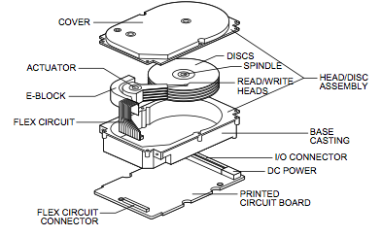

Explanation:

The platters, typically made of aluminum or glass, are stacked on a spindle and rotated by the spindle motor at a constant speed.

Each platter has read/write heads mounted on actuator arms. These arms can move independently across the surface of the platters.

Data is stored on the platters in concentric circular tracks, and the heads read data by detecting changes in magnetic polarity on the surface of the platters.

The actuator moves the arms to position the heads over the correct track, allowing data to be read from or written to the platters.

The controller manages the operation of the HDD, including data transfer between the drive and the computer, error correction, and cache management.

**Chapter 5**

**Data communication and computer network**

1 ) What is computer network. Explain the types of computer network.

A computer network is a collection of interconnected computers and devices that communicate with each other to share resources, data, and information. Networks can be as small as two computers connected together in a home or office setting or as large as a global network like the internet, connecting millions of devices worldwide. Computer networks enable communication and collaboration between users, facilitate the sharing of files and resources, and provide access to remote services and information.

Types of Computer Networks:

1. LAN (Local Area Network): A LAN is a network that covers a small geographical area, typically within a single building or campus. LANs are commonly used in homes, offices, schools, and small businesses to connect computers, printers, and other devices. LANs are usually owned, managed, and controlled by a single organization or individual.
2. WAN (Wide Area Network): A WAN is a network that spans a large geographical area, connecting multiple LANs or other networks over long distances. WANs often utilize public infrastructure such as leased lines, fiber-optic cables, or satellite links to connect distant locations. The internet is the largest example of a WAN, connecting networks and devices worldwide.
3. MAN (Metropolitan Area Network): A MAN is a network that covers a larger geographical area than a LAN but smaller than a WAN, typically spanning a city or metropolitan area. MANs are often used by service providers to connect multiple LANs or buildings within a city to provide high-speed internet access or other services.

2 The basic communication model describes the process of communication between a sender and a receiver. It involves the exchange of messages through a communication channel, with each component playing a specific role in the transmission and reception of information.Explain basic communication model. with its types.

Half-Duplex and Full-Duplex Transmission:

Half-Duplex Transmission: In half-duplex transmission, data can be transmitted in both directions, but not simultaneously. Devices take turns sending and receiving data. It's like a walkie-talkie where one person talks while the other listens, and then they switch roles.

Full-Duplex Transmission: In full-duplex transmission, data can be transmitted simultaneously in both directions. It's like a telephone conversation where both parties can speak and listen at the same time, enabling faster and more efficient communication.

Transmission Speed:

Transmission speed, often measured in bits per second (bps), refers to the rate at which data is transmitted between devices over a communication channel. Higher transmission speeds allow for faster data transfer rates.

Transmission speed depends on various factors including the communication medium (e.g., copper wire, fiber optics), signal encoding techniques, and the capabilities of the transmitting and receiving devices.

Fundamentals of Transmission:

Transmission is the process of sending data from one device to another over a communication channel.

The process involves encoding the data into electrical or optical signals, transmitting these signals through the communication medium, and decoding them at the receiving end to reconstruct the original data.

Analog and Digital Signals:

Analog Signals: Analog signals represent continuous and varying electrical or optical waveforms. They can take on any value within a certain range. Examples include sound waves, voltage signals, and light intensity.

Digital Signals: Digital signals represent discrete and binary values, typically represented as 0s and 1s. They are more resilient to noise and distortion compared to analog signals. Examples include binary data used in computers and digital communication systems.

3 ) differentiate between analog and digital signals.

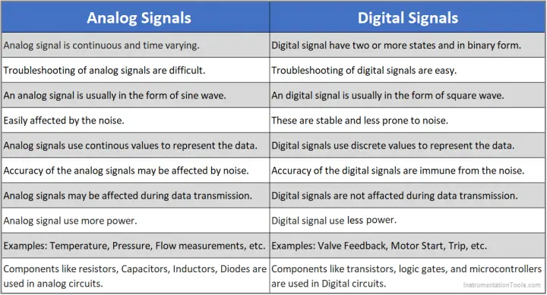

4 ) what are the advantages and disadvantages of computer network?

Advantages of Computer Networks:

Resource Sharing: Computer networks enable the sharing of hardware resources such as printers, scanners, and storage devices, as well as software resources such as applications and databases. This leads to increased efficiency and cost savings.

Communication: Networks facilitate communication between users by providing email, instant messaging, video conferencing, and other collaboration tools. This improves teamwork, coordination, and information exchange within organizations.

Scalability: Computer networks can be easily scaled up or down to accommodate changes in user requirements or business growth. Additional devices, users, or resources can be added to the network as needed without significant disruption.

Cost Savings: By sharing resources and streamlining communication and collaboration, computer networks help reduce costs associated with hardware, software, infrastructure, and maintenance, making them more cost-effective for organizations.

Enhanced Security: Networks allow for the implementation of security measures such as firewalls, encryption, authentication, and access control, helping to protect data and systems from unauthorized access, malware, and cyber threats.

Disadvantages of Computer Networks:

Security Risks: Networks are vulnerable to security risks such as unauthorized access, data breaches, viruses, malware, and hacking. Security measures must be implemented and continuously updated to mitigate these risks.

Complexity: Designing, implementing, and managing computer networks can be complex and require specialized knowledge and skills. Network administrators must ensure proper configuration, monitoring, and maintenance to ensure optimal performance and security.

Bandwidth Limitations: Network bandwidth, the capacity for data transfer, is finite and can become a bottleneck when multiple users or devices compete for resources. This can result in slow network speeds and degraded performance, especially during peak usage periods.

Privacy Concerns: Networks involve the transmission and storage of sensitive information, raising concerns about data privacy, confidentiality, and compliance with regulations such as GDPR and HIPAA. Organizations must implement appropriate privacy safeguards to protect user data.

5 ) Compare and contrast between simplex, half duplex and full duplex.

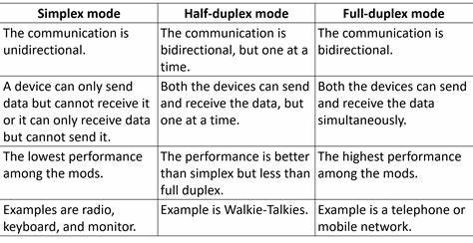

6 ) Compare between LAN, MAN, WAN.

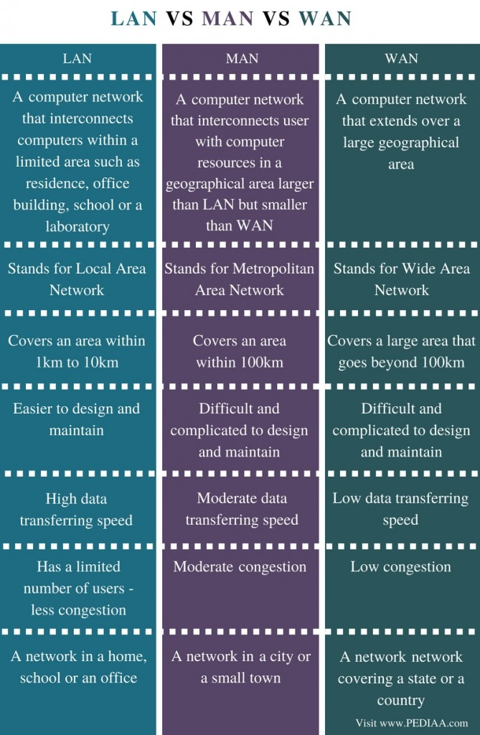

7 ) What is network architecture? What are its types? Network architecture refers to the design and structure of a computer network, including the arrangement of components, protocols, technologies, and communication patterns that define how data is transmitted, routed, and managed within the network. Network architecture provides a framework for organizing and implementing the various elements of a network to meet specific requirements such as performance, scalability, security, and reliability.

Peer-to-Peer (P2P) Architecture:

Definition: Peer-to-peer (P2P) architecture is a decentralized network model where nodes (or peers) in the network have equal status and can act as both clients and servers, sharing resources and services directly with each other without the need for centralized servers.

Characteristics:

Each node in the network can initiate requests for services or data and respond to requests from other nodes.

Peers communicate directly with each other to exchange data, files, or services, without relying on centralized servers.

P2P networks are typically dynamic and self-organizing, with peers joining and leaving the network dynamically.

P2P networks can provide scalability, fault tolerance, and resilience by leveraging distributed resources and avoiding single points of failure.

Examples:

File-sharing networks like BitTorrent, where users can share files directly with each other without relying on a central server.

Distributed computing systems like SETI@home, where volunteers donate their computer's processing power to analyze radio signals from space, collaborating to solve complex computational tasks.

Decentralized applications (DApps) and blockchain networks like Bitcoin and Ethereum, where nodes in the network validate transactions and maintain a distributed ledger without the need for a central authority.

Client-Server Architecture:

Definition: Client-server architecture is a centralized network model where network services and resources are centralized on dedicated servers, and clients request and access these resources over the network.

Characteristics:

Clients (such as computers, smartphones, or IoT devices) initiate requests for services or data, while servers (such as file servers, web servers, or database servers) respond to these requests and provide the requested resources.

Servers are typically more powerful and have higher computing and storage capabilities than clients, allowing them to handle multiple client requests simultaneously.

Client-server architecture enables scalability, centralized management, and access control, making it suitable for enterprise networks, web-based applications, and cloud computing environments.

8 ) Explain different LAN topology.

Local Area Network (LAN) topology refers to the physical or logical layout of network devices, cables, and connections within a local area network. Different LAN topologies determine how devices are interconnected and communicate with each other. Here are some common LAN topologies:

1. Bus Topology:

Description: In a bus topology, all devices are connected to a single communication line (bus) through which data is transmitted. Each device has a unique address, and data transmitted by one device is received by all devices on the bus.

Characteristics:

Simple and inexpensive to implement.

Requires less cabling compared to other topologies.

Susceptible to data collisions and network congestion.

If the main bus cable fails, the entire network may be affected.

2. Star Topology:

Description: In a star topology, all devices are connected to a central hub or switch. Data transmitted by one device is routed through the hub/switch to the intended recipient device. Each device has a dedicated connection to the central hub/switch.

Characteristics:

Provides centralized control and management.

Easy to add or remove devices without disrupting the network.

Fault-tolerant: If one connection or device fails, other devices remain unaffected.

Requires more cabling compared to bus topology.

3. Ring Topology:

Description: In a ring topology, devices are connected in a closed loop or ring configuration, where each device is connected to exactly two other devices, forming a continuous pathway for data transmission.

Characteristics:

Equal access to the network for all devices.

Simple and easy to install and configure.

Susceptible to network failures: If one device or connection fails, the entire network may be disrupted.

Data collisions can occur if multiple devices attempt to transmit data simultaneously.

4. Mesh Topology:

Description: In a mesh topology, devices are interconnected with multiple redundant paths, allowing data to be transmitted through alternative routes if one path fails. Mesh topologies can be full mesh (every device is connected to every other device) or partial mesh (only some devices are directly connected to each other).

Characteristics:

Highly fault-tolerant: Redundant paths ensure network reliability and resilience.

Scalable: Can support a large number of devices.

Complex and expensive to implement: Requires a significant amount of cabling and configuration.

Provides high bandwidth and low latency due to multiple parallel connections.

5. Hybrid Topology:

Description: A hybrid topology combines two or more different types of topologies (such as star-bus, star-ring, or star-mesh) to form a single network.

Characteristics:

Offers flexibility and scalability by combining the advantages of different topologies.

Can accommodate specific network requirements and adapt to changes in network infrastructure.

May require additional planning and management to ensure compatibility and interoperability between different topology segments.

9 ) Write short note on

1. NTC

NTC, standing for Network Time Protocol (NTP) or Network Traffic Control, serves critical functions in network operations. NTP synchronizes device clocks, ensuring accurate time across the network for essential functions like authentication and scheduling. On the other hand, Network Traffic Control optimizes data flow, prioritizing critical traffic, and managing congestion to maintain reliable communication. Together, these mechanisms uphold the efficiency and reliability of network performance.

1. Bridge

A bridge connects two or more network segments, forwarding data packets based on MAC addresses to enable communication between devices. It helps reduce congestion, improve performance, and segment network traffic. A bridge operates at the data link layer (Layer 2) of the OSI model, examining the destination MAC addresses of incoming data packets and forwarding them only to the appropriate network segment. By segmenting the network and isolating traffic, bridges enhance network efficiency and security.

1. Switch

A switch is a networking device that operates at the data link layer (Layer 2) of the OSI model. It is used to connect multiple devices within a LAN (Local Area Network) and selectively forward data packets based on their destination MAC addresses. Unlike hubs, which broadcast data to all connected devices, switches intelligently direct traffic only to the intended recipient, improving network efficiency. Switches can vary in size and port capacity, from small desktop models with a few ports to enterprise-grade switches with hundreds of ports. They are essential components in modern networks, providing high-speed, low-latency connectivity for devices such as computers, printers, and servers.

d) Router

A router is a networking device that operates at the network layer (Layer 3) of the OSI model. It is used to connect multiple networks together and forward data packets between them based on IP addresses. Routers make decisions about the best path for data transmission, using routing tables and algorithms to determine the most efficient route. They provide connectivity between devices in different networks, such as computers, servers, and IoT devices, enabling communication across the internet. Routers can also perform network address translation (NAT) to allow devices with private IP addresses to access the internet using a single public IP address.

10 ) what is OSI model? Explain its layers.

The OSI (Open Systems Interconnection) model is a conceptual framework used to standardize and understand the functions of networking systems. It consists of seven layers, each responsible for specific tasks in the process of transmitting data between devices over a network. Here's an overview of the OSI model layers: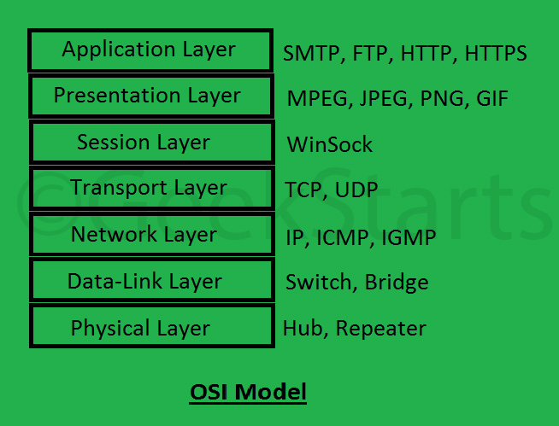

Physical Layer (Layer 1):

The physical layer deals with the physical transmission of data over the network medium, such as copper wires, fiber optics, or wireless signals.

It defines the electrical, mechanical, and procedural specifications for transmitting raw data bits between devices.

Examples of physical layer devices include network cables, hubs, repeaters, and network interface cards (NICs).

Data Link Layer (Layer 2):

The data link layer is responsible for the reliable transmission of data frames between adjacent network nodes over a physical medium.

It performs error detection and correction, as well as framing, addressing, and flow control to ensure data integrity and synchronization.

Ethernet switches and bridges operate at the data link layer, providing local network communication and managing MAC addresses.

Network Layer (Layer 3):

The network layer manages the routing and forwarding of data packets between different networks, using logical addresses (IP addresses) to identify devices and determine the best path for data transmission.

It encapsulates data into packets, adds routing information, and performs logical addressing and fragmentation.

Routers operate at the network layer, connecting multiple networks together and directing traffic based on IP addresses.

Transport Layer (Layer 4):

The transport layer ensures end-to-end communication between devices by providing reliable, error-checked data delivery and flow control.

It segments and reassembles data into smaller units (segments) and manages end-to-end connections, acknowledgments, and error recovery.

TCP (Transmission Control Protocol) and UDP (User Datagram Protocol) are common transport layer protocols, providing connection-oriented and connectionless communication, respectively.

Session Layer (Layer 5):

The session layer establishes, maintains, and terminates communication sessions between devices, allowing them to synchronize and manage data exchange.

It handles session establishment, synchronization, and negotiation, as well as session checkpointing and recovery in case of failures.

Session layer protocols facilitate communication between applications and manage session-related tasks such as authentication and authorization.

Presentation Layer (Layer 6):

The presentation layer is responsible for data translation, encryption, and formatting to ensure that data exchanged between applications is presented in a compatible and understandable format.

It handles data compression, encryption, and conversion between different data formats and character sets.

Presentation layer protocols ensure that data is properly encoded, encrypted, and formatted for transmission and reception.

Application Layer (Layer 7):

The application layer provides network services and interfaces to application software, allowing users to access network resources and services.

It supports application-level protocols and services such as email (SMTP, POP3), web browsing (HTTP), file transfer (FTP), and remote access (SSH, Telnet).

Application layer protocols enable communication and data exchange between different software applications running on networked devices.

11 ) What is the difference between centralized and distributed system?

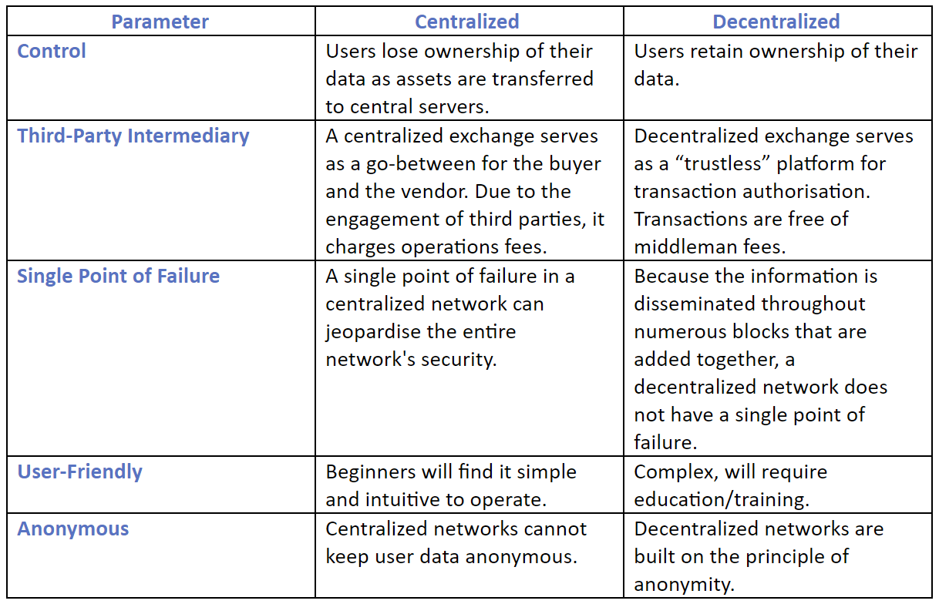

Chapter 6

Internet and world wide web

1. What is internet? Explain the advantages and disadvantages.

The internet is a global network of interconnected computers and devices that use standardized communication protocols to exchange data and information. It enables users worldwide to access a vast array of resources, services, and information through various means such as websites, email, file sharing, streaming media, and online communication platforms. Here's a breakdown of the advantages and disadvantages of the internet:

Advantages of the Internet:

Access to Information: The internet provides instant access to a wealth of information on virtually any topic imaginable, empowering users to learn, research, and educate themselves on a wide range of subjects.

Communication: The internet facilitates real-time communication and collaboration through email, instant messaging, social media, video conferencing, and other online platforms, connecting people across the globe.

E-commerce and Online Services: The internet enables online shopping, banking, booking services, and access to a myriad of digital services, offering convenience, choice, and efficiency for consumers and businesses.

Global Connectivity: The internet transcends geographical boundaries, allowing individuals, businesses, and organizations to connect, share, and collaborate on a global scale, fostering international cooperation and cultural exchange.

Entertainment and Recreation: The internet offers a vast array of entertainment options, including streaming movies, music, games, and social media, providing endless opportunities for leisure and recreation.

Work and Productivity: The internet facilitates remote work, telecommuting, and online collaboration tools, enabling employees to work from anywhere with an internet connection and increasing flexibility and productivity.

Disadvantages of the Internet:

Information Overload: The abundance of information on the internet can lead to information overload, making it difficult for users to filter, evaluate, and discern credible sources from misinformation or unreliable content.

Privacy Concerns: The internet poses privacy risks such as data breaches, identity theft, surveillance, and tracking of online activities, raising concerns about personal privacy, security, and data protection.

Cybersecurity Threats: The internet is vulnerable to various cybersecurity threats such as malware, viruses, phishing scams, hacking attacks, and cyber-espionage, posing risks to individuals, businesses, and critical infrastructure.

Digital Divide: The digital divide refers to the gap between individuals and communities with access to the internet and digital technologies and those without access, exacerbating socioeconomic inequalities and limiting opportunities for underserved populations.

Addiction and Dependency: Excessive internet use can lead to addiction, dependency, and negative impacts on mental health, social relationships, and physical well-being, contributing to issues such as internet addiction disorder (IAD) and digital detoxification.

Misinformation and Disinformation: The internet can be a breeding ground for misinformation, fake news, propaganda, and conspiracy theories, undermining trust in information sources and fueling societal divisions, polarization, and distrust.

2 ) Explain client- server technology with proper diagram.

Client-server technology is a computing architecture that divides tasks or workloads between the client and server machines, with each playing a specific role in the communication process. Here's an explanation along with a diagram:

Explanation:

Client: The client is a device or software application that requests services or resources from the server. Clients can be computers, smartphones, tablets, or any other device capable of connecting to a network and making requests.

Server: The server is a powerful computer or software application that provides services or resources to clients upon request. Servers are dedicated to handling requests from multiple clients simultaneously and fulfilling those requests efficiently.

Communication: In client-server architecture, clients initiate communication by sending requests to the server, which processes the requests and returns the results back to the clients. This communication typically occurs over a network, such as the internet or a local area network (LAN).

Tasks: Clients are responsible for initiating actions or tasks, such as requesting web pages, accessing files, sending emails, or interacting with databases. Servers, on the other hand, are responsible for processing and fulfilling these requests, executing tasks, and delivering responses back to the clients.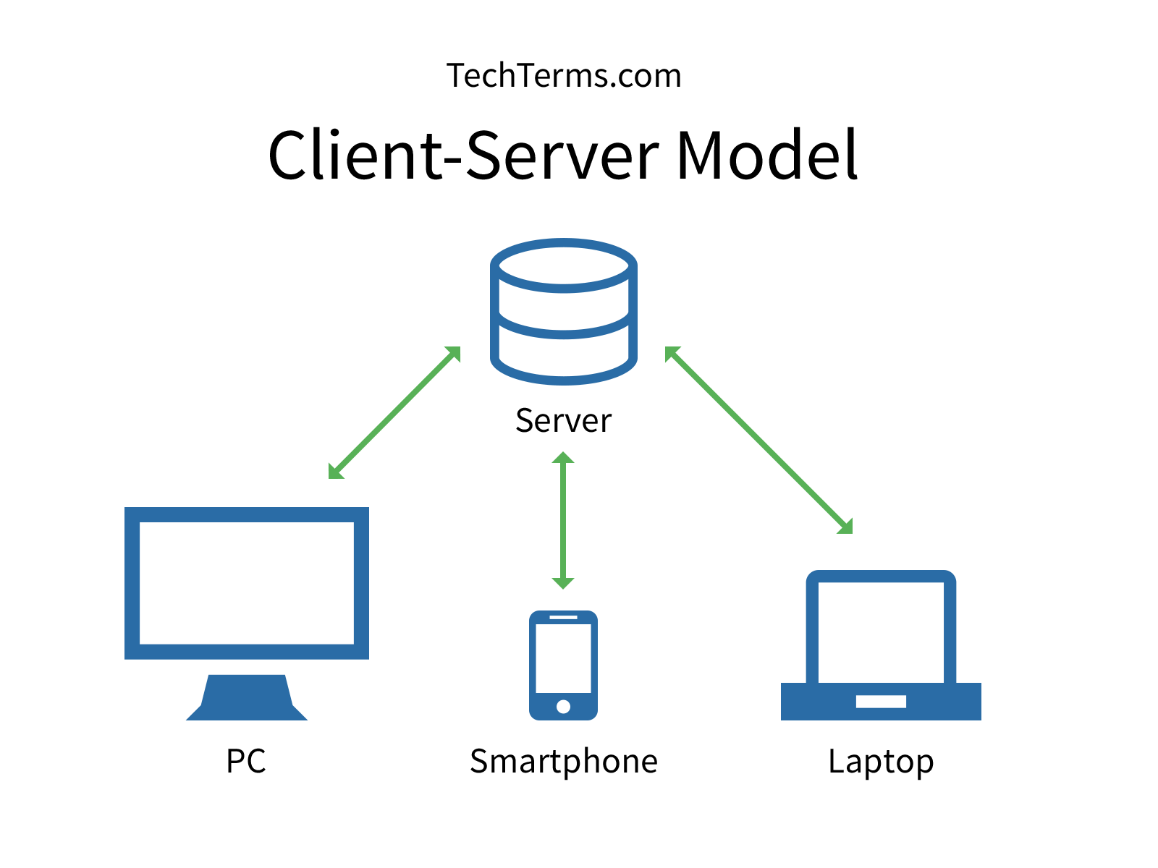

In the diagram:

The client initiates a request (e.g., requesting a web page) and sends it over the network to the server.

The server receives the request, processes it (e.g., retrieves the requested web page from storage), and generates a response.

The response is sent back over the network to the client, which receives and processes it (e.g., rendering the web page for display).

This client-server interaction forms the basis of various applications and services on the internet, such as web browsing, email, file sharing, and database management. It allows for efficient distribution of computing tasks, centralized management of resources, and scalable deployment of services to accommodate varying numbers of clients.

3 ) Write a short note on :

1. Internet Protocol

The Internet Protocol (IP) is a core protocol in computer networking that assigns unique addresses to devices connected to a network, routes data packets between them, and enables communication across interconnected networks. It operates at the network layer of the OSI model and forms the foundation of internet connectivity, facilitating the exchange of data and services worldwide.

1. TCP

TCP, or Transmission Control Protocol, is a fundamental part of internet communication. It ensures reliable data delivery, establishes connections between devices, manages data flow, and prevents network congestion. With TCP, data is transmitted in a secure and orderly manner, forming the backbone of internet communication.

1. FTP

FTP, or File Transfer Protocol, facilitates the transfer of files between a client and a server on a network. It operates on a client-server model, requires authentication for access, supports various commands for file operations, offers modes for data transfer (ASCII and binary), and has options for securing data transmission through protocols like SFTP and FTPS.

1. SMTP

SMTP, or Simple Mail Transfer Protocol, is the standard protocol for sending email messages across networks. It defines the rules and conventions for email communication between mail servers. SMTP operates on a client-server model, where an email client (such as Outlook or Gmail) sends outgoing messages to a mail server, which then routes them to the recipient's mail server for delivery. SMTP is responsible for ensuring reliable delivery of emails, handling error conditions, and supporting features like authentication and encryption for secure communication.

1. Push and POP

Push and POP refer to protocols used in email systems:

Push: In email systems, "push" refers to the process where emails are delivered directly to a client's device as soon as they arrive at the server. This is commonly used in modern email services where devices are constantly connected to the internet, enabling instant delivery of new emails without the need for manual synchronization.

POP (Post Office Protocol): POP is a protocol used by email clients to retrieve emails from a remote server to a local device. It works by downloading emails from the server to the client's device and typically deletes them from the server, although this behavior can be configured. POP is widely supported but lacks synchronization features, meaning actions taken on emails (like marking them as read) on one device may not reflect on others.

4 ) what is internet, intranet and extranet?

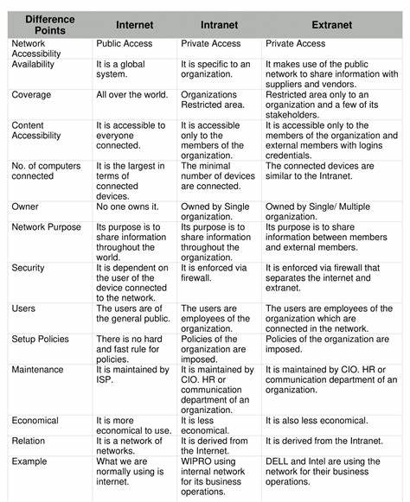

5) What is web- browser? Explain any 3 web- browsers.

A web browser is a software application used to access and navigate the World Wide Web. It allows users to view web pages, multimedia content, and interact with various web-based applications and services. Here are explanations of three popular web browsers:

Google Chrome: Developed by Google, Chrome is one of the most widely used web browsers. It is known for its speed, simplicity, and minimalist design. Chrome offers features like tabbed browsing, bookmarks synchronization across devices, built-in Google search, and a vast library of extensions and plugins. It also includes advanced security features such as Safe Browsing to protect users from malicious websites and phishing attempts.

Mozilla Firefox: Firefox is an open-source web browser developed by the Mozilla Foundation. It is known for its robustness, customization options, and commitment to user privacy. Firefox offers features like tabbed browsing, a built-in spell checker, integrated search, and a wide range of extensions and themes. It prioritizes user privacy with features like Tracking Protection, Enhanced Tracking Protection, and support for third-party privacy-focused extensions.

Microsoft Edge: Originally developed by Microsoft as the successor to Internet Explorer, Edge is a web browser based on the Chromium open-source project. It is designed for speed, security, and compatibility with modern web standards. Edge offers features like tabbed browsing, integration with Microsoft services like Cortana and Office Online, and support for extensions from the Microsoft Edge Add-ons store. It includes built-in security features like SmartScreen for phishing protection and Microsoft Defender SmartScreen for malware protection.

Chapter 7

Contemporary technologies

1. Explain E-commerce. What are the different types of e-commerce?

E-commerce, short for electronic commerce, refers to the buying and selling of goods and services over the internet. It encompasses a wide range of online transactions, including retail sales, digital products, services, and business-to-business (B2B) transactions. E-commerce has become increasingly popular due to its convenience, accessibility, and global reach.

Different types of e-commerce include:

C2C (Consumer-to-Consumer): Transactions between individual consumers facilitated by online platforms or marketplaces. Examples include eBay, Craigslist, and Facebook Marketplace, where individuals can buy and sell used goods directly to each other.

D2C (Direct-to-Consumer): Transactions where manufacturers or producers sell products directly to consumers without intermediaries. Examples include brands like Warby Parker and Casper, which sell their products directly to customers through their own websites or physical stores, bypassing traditional retail channels.

B2B (Business-to-Business): Transactions between businesses, where one business sells products or services to another business. Examples include manufacturers selling products to wholesalers, wholesalers selling to retailers, and businesses purchasing supplies or services from other businesses online. Platforms like Alibaba and ThomasNet facilitate B2B transactions.

G2B (Government-to-Business): Transactions where government entities provide services or sell products to businesses. Examples include government agencies offering procurement opportunities for businesses to bid on contracts or providing licensing and regulatory services to businesses.

G2G (Government-to-Government): Transactions between government entities, involving the exchange of goods, services, or information. Examples include intergovernmental collaborations for sharing resources, information sharing between government agencies, or diplomatic exchanges between countries.

1. What is E-governance? What are its advantages?

E-governance, short for electronic governance, refers to the use of information and communication technologies (ICTs) by government agencies to enhance the delivery of public services, improve efficiency in administrative processes, and promote transparency and accountability in governance. It involves the integration of digital technologies into various aspects of governance to facilitate interactions between government and citizens, businesses, and other government entities.

Advantages of e-governance include:

Improved Accessibility: E-governance enables citizens to access government services and information conveniently from anywhere, at any time, using digital devices such as computers, smartphones, and tablets. This improves accessibility, especially for people in remote areas or with mobility constraints.

Enhanced Efficiency: Digitalization of government processes streamlines administrative tasks, reduces paperwork, and automates routine processes, leading to improved efficiency and productivity in government operations. This allows government agencies to deliver services more quickly and cost-effectively.

Transparency and Accountability: E-governance promotes transparency by providing citizens with access to government information, policies, and decisions through online portals and databases. It enhances accountability by enabling citizens to monitor government activities, track the use of public funds, and hold officials accountable for their actions.

Citizen Engagement: E-governance fosters greater citizen participation in governance processes by providing platforms for feedback, consultation, and collaboration between government and citizens. Online forums, social media channels, and interactive websites allow citizens to voice their opinions, contribute ideas, and participate in decision-making processes.

Cost Savings: By digitizing processes and reducing reliance on paper-based systems, e-governance helps governments save costs associated with printing, storage, and distribution of documents. It also reduces the need for physical infrastructure and personnel for delivering services, leading to cost savings in the long run.

Data-driven Decision Making: E-governance generates vast amounts of data on citizen interactions, service delivery, and government performance. Analyzing this data enables policymakers to make informed decisions, identify areas for improvement, and allocate resources more effectively to address the needs of citizens.

1. Explain AI, Robotics, Bitcoin, Virtual Reality, Ambient intelligence, GIS, Hyper media with their advantages and disadvantages.

Artificial Intelligence (AI):

Definition: AI refers to the simulation of human intelligence processes by machines, including learning, reasoning, and problem-solving.

Advantages:

Automation of repetitive tasks, leading to increased efficiency and productivity.

Improved decision-making through data analysis and predictive modeling.

Enhanced personalization of services and experiences for users.

Disadvantages:

Ethical concerns regarding job displacement and algorithmic biases.

Potential for misuse and unintended consequences, such as privacy violations and algorithmic discrimination.

Complexity and difficulty in interpreting and debugging AI systems.

Robotics:

Definition: Robotics involves the design, construction, operation, and use of robots to perform tasks autonomously or with human guidance.

Advantages:

Automation of dangerous, repetitive, or labor-intensive tasks, reducing human risk and improving safety.

Increased precision and accuracy in manufacturing and other industries.

Assistance for people with disabilities or special needs through robotic prosthetics and assistive devices.

Disadvantages:

High initial costs associated with development, deployment, and maintenance of robotic systems.

Concerns about job displacement and the impact on employment in certain industries.

Ethical considerations regarding the use of autonomous robots in decision-making and military applications.

Bitcoin:

Definition: Bitcoin is a decentralized digital currency that operates on a peer-to-peer network, allowing users to send and receive payments without the need for intermediaries like banks.

Advantages:

Decentralization and transparency of transactions, reducing reliance on central authorities and intermediaries.

Lower transaction fees compared to traditional banking systems, especially for international transfers.

Protection against inflation and currency devaluation due to limited supply and cryptographic security.

Disadvantages:

Volatility and speculative nature of Bitcoin prices, leading to investment risks and uncertainty.

Concerns about security and susceptibility to hacking, fraud, and theft.

Regulatory challenges and legal uncertainties regarding the use of Bitcoin for illicit activities and tax evasion.

Virtual Reality (VR):

Definition: Virtual Reality is a computer-generated simulation of a three-dimensional environment that users can interact with using specialized hardware and software.

Advantages:

Immersive experiences for entertainment, gaming, education, training, and simulations.

Enhanced visualization and understanding of complex data, concepts, and environments.

Remote collaboration and communication in virtual spaces, overcoming geographical barriers.

Disadvantages:

High costs of VR hardware and software, limiting accessibility for some users and applications.

Potential for motion sickness and discomfort, especially with prolonged use.

Social isolation and disconnection from reality, raising concerns about psychological effects and addiction.

Ambient Intelligence:

Definition: Ambient Intelligence refers to a network of interconnected devices and sensors that seamlessly integrate into the environment to provide context-aware and adaptive services.

Advantages:

Automation of routine tasks and personalized assistance based on user preferences and behavior.

Improved efficiency and energy conservation through smart control of devices and systems.

Enhanced user experience and convenience through seamless integration of technology into everyday life.

Disadvantages:

Privacy concerns related to data collection, monitoring, and surveillance in ambient intelligence systems.

Security vulnerabilities and risks of unauthorized access, hacking, and misuse of personal data.

Dependency on technology and loss of control over individual autonomy and decision-making.

GIS (Geographic Information System):

Definition: GIS is a system designed to capture, store, analyze, manage, and present spatial or geographic data.

Advantages:

Improved spatial analysis and decision-making in various fields, including urban planning, environmental management, and emergency response.

Integration of diverse data sources and visualization of complex spatial relationships for better understanding and communication.

Enhanced collaboration and information sharing among stakeholders through interactive maps and geospatial applications.

Disadvantages:

Complexity and technical expertise required for GIS data collection, processing, and interpretation.

Costly software and hardware investments, as well as ongoing maintenance and training expenses.

Challenges related to data quality, accuracy, and interoperability, especially when integrating heterogeneous data from different sources.

Hypermedia:

Definition: Hypermedia is an extension of the term hypertext, which refers to a text with hyperlinks embedded within it. Hypermedia includes not only text but also other forms of media such as images, audio, video, and interactive elements like buttons and forms, all of which are interconnected through hyperlinks.

Advantages:

Enhanced user engagement and interactivity by providing multimedia content and interactive features.

Facilitates nonlinear navigation, allowing users to explore content in a nonsequential manner.

Supports richer and more immersive user experiences compared to traditional text-based media.

Disadvantages:

Requires higher bandwidth and storage capacity to accommodate multimedia content, which may lead to slower loading times and higher data consumption.

Complexity in design and implementation, especially when integrating diverse media types and ensuring cross-platform compatibility.

Accessibility challenges for users with disabilities, as multimedia content may present barriers to those with visual or hearing impairments.